Supplemental Information
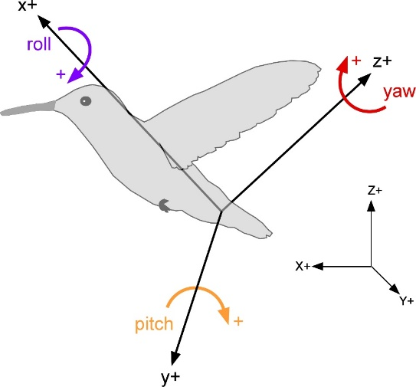

Figure S1. Global (X, Y, Z) and bird-centered (x, y, z) coordinate systems.
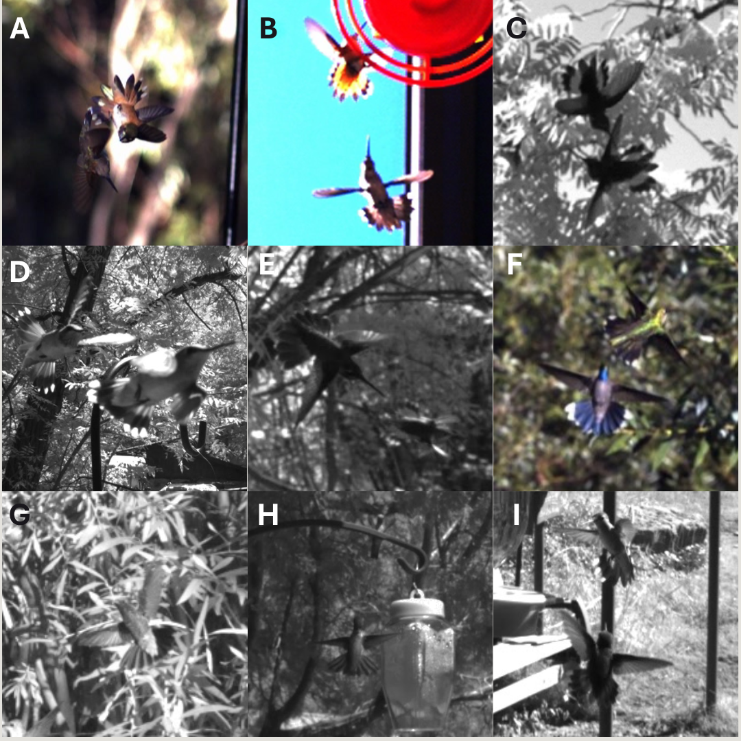
Figure S2. Compilation of flared tails in wild hummingbirds of Arizona. A) rufous (Selasphorus rufus, right), chasing black-chinned (Archilochus alexandri, left), B) rufous (top) and black-chinned in contest at feeder (red disc), C) two rufous in ascending fight, D) black-chinned (left) chasing conspecific, E) Rivoli’s (Eugenes fulgens) chasing a rufous, F) blue-throated mountain-gem (Lampornis clemenciae) intimidating a black-chinned, G) Broad-billed (Cynanthus latirostris) signaling a bird out of frame, H) dorsal view of Anna's (Calypte anna) facing conspecific, I) Calliope (Selasphorus calliope) in the foreground signaling to a black-chinned at a feeder.

Link
Video S1: Multiple views of tail flaring by a male calliope hummingbird (Selasphorus calliope) displaying to a perched male in our combat arena. The displaying male was ranked #1 for being the most dominant bird in our indoor fight trials. Original video sampled at 2000 frames s⁻¹, with playback at 200 frames s⁻¹.

Table S1. Coefficients of variance (CV) in length of the bill and width of the rump digitized from male calliope hummingbirds (Selasphorus calliope). We include each combination of behavior and individual in our experiments in the combat arena. Rump widths changed as the hummingbirds flared their tails, therefore, we report the Pearson correlation coefficient between rump width and tail angle. In our methods of quality control, we ensured CV < 5% for fixed length of a given bird’s bill.

Bird Rank | Treatment & Outcome | Bill CV | Rump CV | Pearson Correlation Coefficient
3 | Competition (Win) | 2.06 | 27.34 | 0.90
3 | Competition (Loss) | 3.61 | 14.04 | 0.46
3 | Landing | 4.35 | 6.39 | -0.43
3 | Takeoff | 3.55 | 6.00 | -0.41
4 | Competition (Loss) | 2.25 | 13.13 | 0.48
4 | Competition (Win) | 2.04 | 15.73 | 0.96
4 | Landing | 2.51 | 6.03 | -0.47
4 | Takeoff | 4.07 | 7.50 | 0.76
1 | Competition (Loss) | 2.65 | 10.80 | 0.79
1 | Competition (Win) | 2.40 | 13.12 | 0.85
1 | Takeoff | 4.01 | 8.08 | -0.31
1 | Landing | 3.79 | 4.92 | -0.52
5 | Competition (Loss) | 3.35 | 14.62 | 0.83
5 | Competition (Win) | 2.18 | 10.95 | 0.30
5 | Landing | 3.89 | 10.31 | -0.83
5 | Takeoff | 3.98 | 18.58 | -0.55
2 | Competition (Loss) | 2.37 | 8.07 | 0.02
2 | Competition (Win) | 1.78 | 14.66 | 0.69
2 | Takeoff | 3.91 | 11.46 | -0.51
2 | Landing | 4.43 | 15.42 | -0.74

